|  |  |
| --- | --- |
| Student Name | <<enter Full Name >> |
| SRN No | <<enter SRN No >> |
| Roll No | <<Enter Roll No>> |
| Program | <<AIDS / Computer Engg.>> |
| Year | Third Year |
| Division | <<Enter division>> |
| Subject | Computer Network Laboratory (BTECCE22506) |
| Assignment No | Four |

Assignment Number - 04

**Title :** Configuration of router by using router commands and implementation of static routing

**Problem Statement** Using a Network Simulator (e.g. packet tracer) Configure routers for static routing

**Theory :**

**Router –** Router is a network device that allows you to direct data traffic to an appropriate destination. Router maintain routing table that contain IP addresses of computers over the network. A router has different components that enable proper functioning.

**Cisco IOS supports various command modes, among those followings are the main command modes.**

• User EXEC Mode

• Privileged EXEC Mode

• Global Configuration Mode

• Interface Configuration Mode

• Sub Interface Configuration Mode

• Setup Mode

|  |  |  |  |
| --- | --- | --- | --- |
| **Mode** | **Prompt** | **Command to enter** | **Command to exit** |
| User EXEC | Router > | Default mode after booting. Login  with password, if configured. | Use **exit** command |
| Privileged EXEC | Router # | Use **enable** command from user  exec mode | Use **exit** command |
| Global | Router(config)# | Use **configure terminal** command  from privileged exec mode | Use **exit** command |
| Configuration |
| Interface | Router(config-if)# | Use **interface** | Use **exit** command to  return in global configuration mode |
| Configuration | **type *number*** command from  global configuration mode |
| Sub-Interface | Router(config-subif) | Use **interface type *sub interface***  ***number***command from global configuration mode or interface configure mode | Use **exit** to return  previous mode. Use **end** command to return in privileged exec mode. |
| Configuration |

**Some important router Command**

|  |  |  |  |
| --- | --- | --- | --- |
| **Command** | | | **Description** |
| Router(config)#interface serial 0/0/0 | | | Enter into serial interface 0/0/0  configuration mode |
|
| Router(config-if)#description | Connected | to | Optional command. It set description on |
| interface |  |  | interface that is locally significant |
| Router(config-if)#ip address 10.0.0.1 | | | Assigns address and subnet mask to  interface |
| 255.0.0.0 | | |
| Router(config-if)#clock rate 64000 | | | DCE side only command. Assigns a clock  rate for the interface |
|
| Router(config-if)#bandwidth 64 | | | DCE side only command. Set bandwidth for  the interface. |
|
| Router(config-if)#no shutdown | | | Turns interface on |

**Configuration of static Routing**

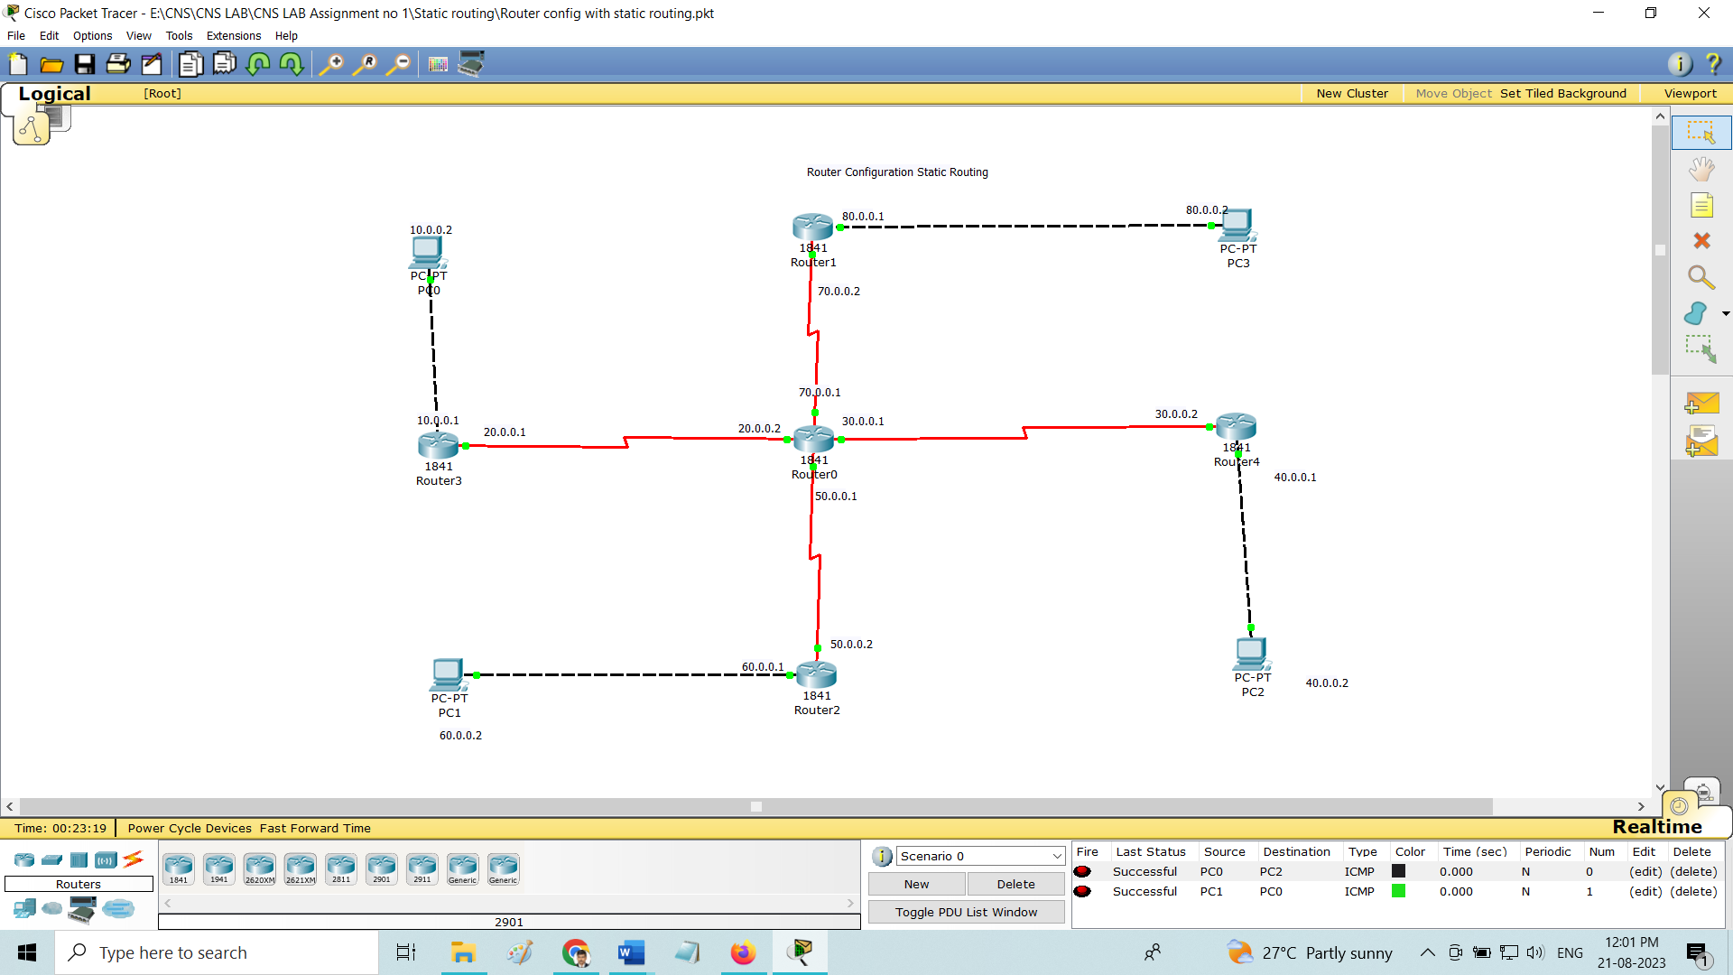

**Code**

**Basic Router Configuration – Static Routing**

**Router0 Configuration**

Router>enable

Router#configure terminal

Enter configuration commands, one per line. End with CNTL/Z.

Router(config)#interface Serial0/1/0

Router(config-if)#ip address 20.0.0.2 255.0.0.0

Router(config-if)#no shutdown

Router(config-if)#

%LINK-5-CHANGED: Interface Serial0/1/0, changed state to up

%LINEPROTO-5-UPDOWN: Line protocol on Interface Serial0/1/0, changed state to up

Router(config-if)#exit

Router(config)#interface Serial0/0/0

Router(config-if)#ip address 30.0.0.1 255.0.0.0

Router(config-if)#no shutdown

Router(config-if)#

%LINK-5-CHANGED: Interface Serial0/0/0, changed state to up

Router(config-if)#exit

Router(config)#interface Serial0/0/1

Router(config-if)#

%LINEPROTO-5-UPDOWN: Line protocol on Interface Serial0/0/0, changed state to up

ip address 50.0.0.1 255.0.0.0

Router(config-if)#no shutdown

Router(config-if)#

%LINK-5-CHANGED: Interface Serial0/0/1, changed state to up

Router(config-if)#exit

Router(config)#interface Serial0/1/1

Router(config-if)#ip address 70.0.0.1 255.0.0.0

Router(config-if)#

%LINEPROTO-5-UPDOWN: Line protocol on Interface Serial0/0/1, changed state to up

no shutdown

Router(config-if)#

%LINK-5-CHANGED: Interface Serial0/1/1, changed state to up

%LINEPROTO-5-UPDOWN: Line protocol on Interface Serial0/1/1, changed state to up

Router(config)#ip route 10.0.0.0 255.0.0.0 20.0.0.1

Router(config)#ip route 80.0.0.0 255.0.0.0 70.0.0.2

Router(config)#ip route 40.0.0.0 255.0.0.0 30.0.0.2

Router(config)#ip route 60.0.0.0 255.0.0.0 50.0.0.2

Router#show ip route

Codes: C - connected, S - static, I - IGRP, R - RIP, M - mobile, B - BGP

D - EIGRP, EX - EIGRP external, O - OSPF, IA - OSPF inter area

N1 - OSPF NSSA external type 1, N2 - OSPF NSSA external type 2

E1 - OSPF external type 1, E2 - OSPF external type 2, E - EGP

i - IS-IS, L1 - IS-IS level-1, L2 - IS-IS level-2, ia - IS-IS inter area

* - candidate default, U - per-user static route, o - ODR

P - periodic downloaded static route

Gateway of last resort is not set

S 10.0.0.0/8 [1/0] via 20.0.0.1

C 20.0.0.0/8 is directly connected, Serial0/1/0

C 30.0.0.0/8 is directly connected, Serial0/0/0

S 40.0.0.0/8 [1/0] via 30.0.0.2

C 50.0.0.0/8 is directly connected, Serial0/0/1

S 60.0.0.0/8 [1/0] via 50.0.0.2

C 70.0.0.0/8 is directly connected, Serial0/1/1

S 80.0.0.0/8 [1/0] via 70.0.0.2

Router#

**Router1 Configuration**

Router>enable

Router#configure terminal

Enter configuration commands, one per line. End with CNTL/Z.

Router(config)#interface FastEthernet0/0

Router(config-if)#ip address 80.0.0.1 255.0.0.0

Router(config-if)#no shutdown

Router(config-if)#

%LINK-5-CHANGED: Interface FastEthernet0/0, changed state to up

%LINEPROTO-5-UPDOWN: Line protocol on Interface FastEthernet0/0, changed state to up

Router(config-if)#exit

Router(config)#interface Serial0/0/0

Router(config-if)#ip address 70.0.0.2 255.0.0.0

Router(config-if)#no shutdown

Router(config-if)#

Router(config)#ip route 10.0.0.0 255.0.0.0 70.0.0.1

Router(config)#ip route 20.0.0.0 255.0.0.0 70.0.0.1

Router(config)#ip route 30.0.0.0 255.0.0.0 70.0.0.1

Router(config)#ip route 40.0.0.0 255.0.0.0 70.0.0.1

Router(config)#ip route 50.0.0.0 255.0.0.0 70.0.0.1

Router(config)#ip route 60.0.0.0 255.0.0.0 70.0.0.1

**Router2 Configuration**

Router>enable

Router#configure terminal

Enter configuration commands, one per line. End with CNTL/Z.

Router(config)#interface FastEthernet0/0

Router(config-if)#ip address 60.0.0.1 255.0.0.0

Router(config-if)#no shutdown

Router(config-if)#

%LINK-5-CHANGED: Interface FastEthernet0/0, changed state to up

%LINEPROTO-5-UPDOWN: Line protocol on Interface FastEthernet0/0, changed state to up

Router(config-if)#exit

Router(config)#interface Serial0/0/0

Router(config-if)#no shutdown

Router(config-if)#exit

Router(config)#interface Serial0/0/0

Router(config-if)#ip address 50.0.0.2 255.0.0.0

Router(config-if)#

Router(config)#ip route 10.0.0.0 255.0.0.0 50.0.0.1

Router(config)#ip route 20.0.0.0 255.0.0.0 50.0.0.1

Router(config)#ip route 30.0.0.0 255.0.0.0 50.0.0.1

Router(config)#ip route 40.0.0.0 255.0.0.0 50.0.0.1

Router(config)#ip route 70.0.0.0 255.0.0.0 50.0.0.1

Router(config)#ip route 80.0.0.0 255.0.0.0 50.0.0.1

Router(config)#

**Router3 Configuration**

Router>enable

Router#configure terminal

Enter configuration commands, one per line. End with CNTL/Z.

Router(config)#interface FastEthernet0/0

Router(config-if)#ip address 10.0.0.1 255.0.0.0

Router(config-if)#no shutdown

Router(config-if)#

%LINK-5-CHANGED: Interface FastEthernet0/0, changed state to up

%LINEPROTO-5-UPDOWN: Line protocol on Interface FastEthernet0/0, changed state to up

Router(config-if)#exit

Router(config)#interface Serial0/0/0

Router(config-if)#ip address 20.0.0.1 255.0.0.0

Router(config-if)#clock rate 64000

Router(config-if)#no shutdown

Router(config-if)#

Router(config)#ip route 30.0.0.0 255.0.0.0 20.0.0.2

Router(config)#ip route 40.0.0.0 255.0.0.0 20.0.0.2

Router(config)#ip route 50.0.0.0 255.0.0.0 20.0.0.2

Router(config)#ip route 60.0.0.0 255.0.0.0 20.0.0.2

Router(config)#ip route 70.0.0.0 255.0.0.0 20.0.0.2

Router(config)#ip route 80.0.0.0 255.0.0.0 20.0.0.2

Router(config)#

Router#

%SYS-5-CONFIG_I: Configured from console by console

Router#

Router#show ip route

Codes: C - connected, S - static, I - IGRP, R - RIP, M - mobile, B - BGP

D - EIGRP, EX - EIGRP external, O - OSPF, IA - OSPF inter area

N1 - OSPF NSSA external type 1, N2 - OSPF NSSA external type 2

E1 - OSPF external type 1, E2 - OSPF external type 2, E - EGP

i - IS-IS, L1 - IS-IS level-1, L2 - IS-IS level-2, ia - IS-IS inter area

* - candidate default, U - per-user static route, o - ODR

P - periodic downloaded static route

Gateway of last resort is not set

C 10.0.0.0/8 is directly connected, FastEthernet0/0

C 20.0.0.0/8 is directly connected, Serial0/0/0

S 30.0.0.0/8 [1/0] via 20.0.0.2

S 40.0.0.0/8 [1/0] via 20.0.0.2

S 50.0.0.0/8 [1/0] via 20.0.0.2

S 60.0.0.0/8 [1/0] via 20.0.0.2

S 70.0.0.0/8 [1/0] via 20.0.0.2

S 80.0.0.0/8 [1/0] via 20.0.0.2

**Router4 Configuration**

Router>enable

Router#configure terminal

Enter configuration commands, one per line. End with CNTL/Z.

Router(config)#interface FastEthernet0/0

Router(config-if)#ip address 40.0.0.1 255.0.0.0

Router(config-if)#no shutdown

Router(config-if)#

%LINK-5-CHANGED: Interface FastEthernet0/0, changed state to up

%LINEPROTO-5-UPDOWN: Line protocol on Interface FastEthernet0/0, changed state to up

Router(config-if)#exit

Router(config)#interface Serial0/0/0

Router(config-if)#ip address 30.0.0.2 255.0.0.0

Router(config-if)#clock rate 64000

This command applies only to DCE interfaces

Router(config-if)#no shutdown

Router(config-if)#do write

Building configuration...

[OK]

Router(config-if)#

Router#config t

Enter configuration commands, one per line. End with CNTL/Z.

Router(config)#ip route 10.0.0.0 255.0.0.0 30.0.0.1

Router(config)#ip route 20.0.0.0 255.0.0.0 30.0.0.1

Router(config)#ip route 50.0.0.0 255.0.0.0 30.0.0.1

Router(config)#ip route 60.0.0.0 255.0.0.0 30.0.0.1

Router(config)#ip route 70.0.0.0 255.0.0.0 30.0.0.1

Router(config)#ip route 80.0.0.0 255.0.0.0 30.0.0.1

**Conclusion :** <<Write Conclusion in your own words. Write about what you learn from assignment>>